**FINAL REPORT**

**Capstone Project –The Battle of Neighborhoods**

1. **INTRODUCTION**

Toronto is the capital city of the Canadian province of Ontario. The land area of Toronto (City) is 630.20 square kilometers and the population density was 4,334.4 people per square kilometer. As per the records around 47% of the populations of Toronto are the immigrants from different parts of the world. Out of these immigrants, a major portion is Asians out of which Indians are dominating. As we know, there are many Indian students and Indian workers are living in Canada. Around 643,370 Indians are living in Toronto alone as per the 2016 census. The studies showing that the number of Indian immigrants is increasing steeply in the past years and we are expecting the same in coming years.

Since these many Indians are living in Toronto, opening an Indian restaurant in Toronto will be a great idea for the business groups. Already there will be some restaurants providing Indian foods in Toronto. So while opening a new restaurant, we have to analyze the Neighborhoods of Toronto. Here we can introduce our data science techniques to locate the proper place in Toronto to open a new Indian restaurant.

* 1. **Problem :**

Analyze the neighborhoods of Toronto to find

1. The suitable location to open a new Indian Restaurant
2. The Indian Restaurant with good rating

This project will be useful for the investors, who are planning to start an Indian restaurant business in Toronto and the analysis will be useful for the Indian community who are living in Toronto to identify the good Indian restaurants already located in Toronto.

1. **DATA SECTION**
   1. **Data Source**

* For getting the postal codes and boroughs in Toronto, we are using the Wikipedia data from the below page :

<https://en.wikipedia.org/wiki/List_of_postal_codes_of_Canada:_M>

* For getting the latitudes and longitudes of each postal codes in Toronto, we are using below link :

<http://cocl.us/Geospatial_data>

* For getting the various venues in Toronto, especially Indian Restaurants we are using Foursqare API.

We have to create an account in <https://developer.foursquare.com/>

* 1. **Data Preprocessing**

We have to do a scraping of the Toronto neighborhood data and using the latitudes and longitudes have to create a data frame for the analysis. During this process we will clean the data to remove some inappropriate data for our proper analysis.

1. **Methodology**
2. Fetch the data from Wikipedia page

<https://en.wikipedia.org/wiki/List_of_postal_codes_of_Canada:_M> and converted it into a data frame. Perform some data cleaning and merge with the latitude and longitude data frame.

1. I planned to analyze only the borough name contains Toronto. So created a data frame for Toronto Borough.

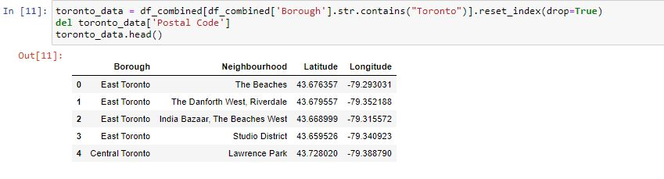

1. The next step was to find total number of Indian restaurant present in Toronto.

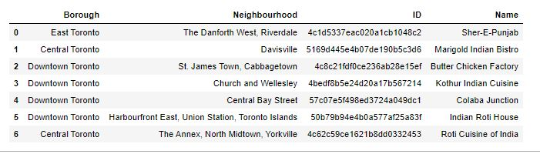

There are only 7 Indian restaurants in Toronto.

1. Then I calculated how many Indian restaurants are there in each borough.

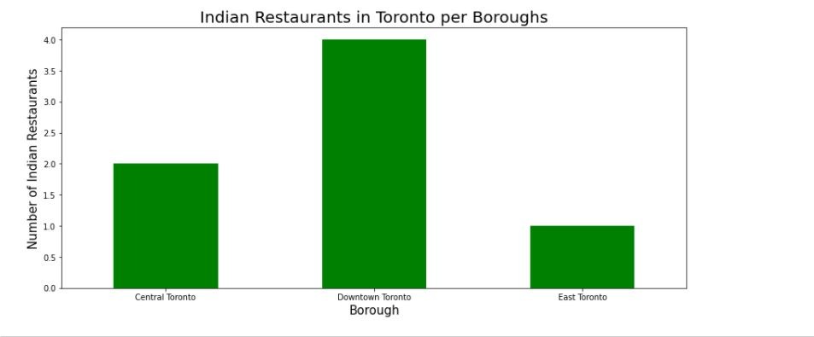 Downtown Toronto was having the most number of Indian restaurants.

1. Next step was to analyze the rating of the Indian restaurants running in Toronto per each borough as well as neighborhood.

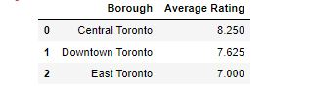

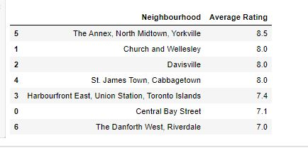

1. The plot the map of Indian restaurants in Toronto

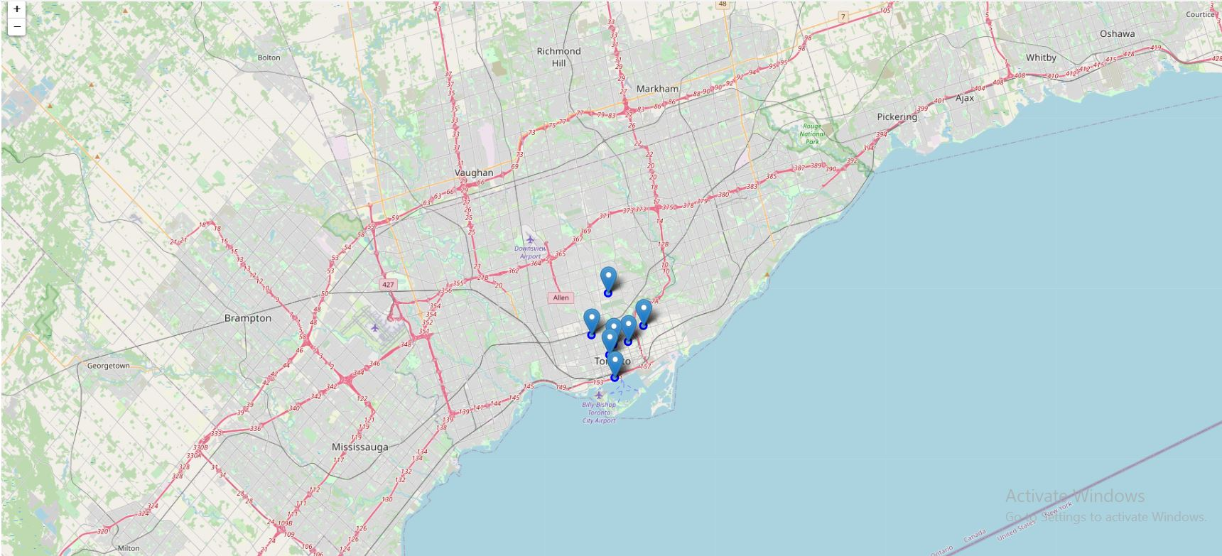

1. **RESULT SECTION**

As per the data analysis I have performed, I am arrived at the following result.

* 1. There are 7 Indian restaurants currently running in Toronto.
  2. Downtown Toronto has most number of Indian restaurants. That is 4. So it is a better place for Indians to line in Toronto.
  3. Central Toronto is the borough with an Indian restaurant having highest average rating.
  4. East Toronto is the borough with lowest number of Indian restaurants. So it is the best place to start a new Indian restaurant.

1. **CONCLUSION**

As per the data analysis I have performed as part of Capstone project, I have arrived at the solutions for questions which discussed at the beginning of this project. This was done based on the data readily available in internet and with the help of Foursqare API. This will be useful for the business persons who are thinking about starting a new Indian restaurant in Toronto. This study can be improved with latest data.